*Heaven’s light is our guide.*

**Rajshahi University of Engineering and Technology**

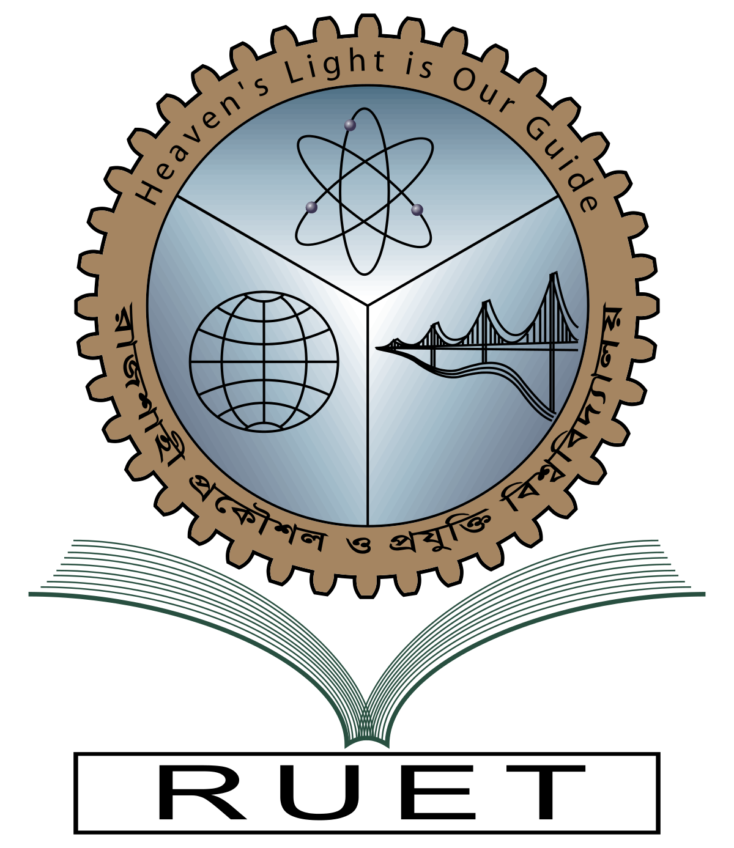

**Department of Electrical & Electronic Engineering**

**Course no.** EEE 4210

**Course title:** Embedded System Design Sessional

**Experiment no.** 4

**Experiment name:** Study of R-2R ADC & generation of different signals using Arduino microcontroller & designing PLL block

**Date of experiment:** December 13, 2023

**Date of submission:** January 03, 2023

|  |  |
| --- | --- |
| **Submitted to:** | **Submitted by:** |
| **Md. Razon Chowdhury**  **Assistant Professor**  Dept. of Electrical & Electronic Engineering,  Rajshahi University of Engineering and Technology. | **Ashraf Al- Khalique**  **Roll:** 1801171  **Session:** 2018-2019  Dept. of Electrical & Electronic Engineering,  Rajshahi University of Engineering and Technology. |